# Homework 2: Mastering the Basics of SQL Server

(**Task 1: 5 points**) Complete Task #2 through Task #4 while placing your sql files in Queries. Show in a screenshot that your Homework 2 project in Solution Explorer contains **three** sql files in **Solution Explorer**.

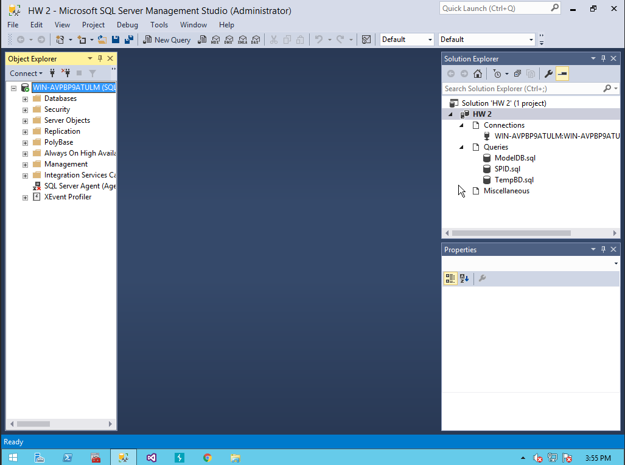

**(Task 2: 5 points**) Show in a screenshot that **DatabaseLog_test** table is created in **MyDatabase2**, and **not** in **MyDatabase1**.

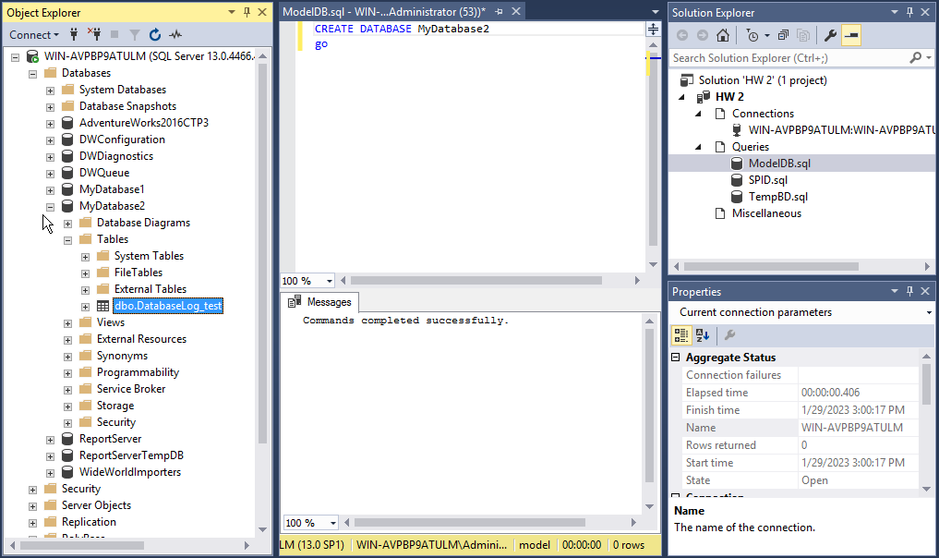

(**Task 3: 4 points**) Create the three temp tables listed above and show their existence using the SELECT command above. Attach a screenshot.

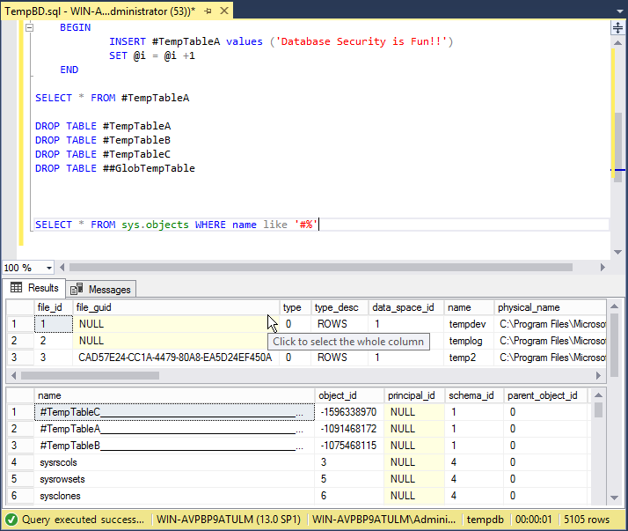

(**Task 4: 5 points**) Fill in **all** the blanks. Keep in mind that you have made a connection via a dynamic port not the default number. Your answers to the second column must be consistent with the connection you made.

|  |  |  |
| --- | --- | --- |
|  | **Name/Number** | **Description (definition)** |
| SPID |  |  |
| SID |  |  |
| principal_id |  |  |
| net_library |  |  |
| local_tcp_port |  |  |

In addition, show the result of each of the four queries in a screenshot.